2022 ASTU “Optimal Control”

~ 1950: Transfer Function analysis –Bode plot, Stability

~ 1960: State Space analysis – Optimal Control – State feedback / Observer design

~ 1980: Robust analysis – H_infinity, MIMO

(~1990 : AI, Image Process, Speech recognition)

(~2000 : Machine learning, Neural network)

* Now machine is evolving to learn faster than human !
* What’s role of control engineer in this “Data Period”?

We, control engineer, should follow and catch the trends of Data period.

We, should know the basic control values…

-What is the In-Out relation?

-What sensors are using?

-How to control an uncertain system?

The classical control have done to answer these fundamental questions, and it will be advanced. In control respective, how about machine learning? There are several examples in matlab. But the fundamental questions are not cleared answered. I hope we may understand ML a littler bit to contribute to control knowledge.

In this semester, I would like to study optimal control in two respects

1. Modeled system optimal control : matlab , “chebfun”
2. Un-modeled system optimal control : ML , “Jupiter note-book”

Topics in detail are

* Calculus of variations: Euler, Hamilton-Jacobi-Bellman equation(HJB)
* Linear optimal control system :continuous and discrete system

--Linear quadratic regulator(LQR): continuous system, discrete system

--Linear quadratic Gaussian (LQG)

* dynamic programming
* introduction to machine learning - neural network
* Reinforcement learning optimal control
* References

- main: “Optimal control” 3rd edition, F.Lewis, 2012

-“Applied Optimal Control: Optimization, Estimation and Control”, E.Bryson,1975.

-“Linear Optimal control system”,Sivan, Kwakernaak, 1972

-“Data-Driven Science and Engineering, Machine Learning, Dynamic Systems and Control”,S.Bruton, 2019.

Now let us start to one step for these goal.

1. Static Optimization
   1. Optimization without constraints

A scalar performance index $L\left(u\right),$ find $u ∈R^{n}$: control or decision vector,

$$\min_{u}{L(u)}$$

In the Taylor series,

$$dL=L_{u}^{T}du+\frac{1}{2}du^{T}L_{uu}du+O(3)$$

Gradient: $L_{u}=\frac{∂L}{∂u}$

Hessian : $L_{uu}=\frac{∂^{2}L}{∂u^{2}}$

Stationary point ( critical point) $u^{*}$: $L_{u^{*}}=0$

If 🡪 is minimized at $u^{*}$

* Ex. 1.1-2

$$L\left(u_{1}, u_{2}\right)=\frac{1}{2}u_{1}^{2}+u_{1}u_{2}+u_{2}^{2}+u_{2}$$

Then from $\frac{∂L}{∂u_{1}}=\frac{∂L}{∂u_{2}}=0 ,$ $u_{1}=1, u_{2}=-1$% The End %

* 1. Optimization with Equality Constraints

Find $u^{*}$ s.t. $L\left(u^{*},x^{*}\right)=\min{L(u,x)}$ (1)

with the constraints $f\left(x,u\right)=0$ (2)

* State vector $x={\left[x_{1},x_{2},…, x_{n}\right]}^{T}$
* Constraint vector $f={\left[f_{1},f_{2},…,f_{n}\right]}^{T}, f(x,u)=0$
* Performance Index $L(x,u)$
* **Lagrange Multiplier: $λ$**

Introduce a new variable $λ$, “costate”, so that define $H \left(x,u,λ\right)$ is to “adjoin” the constraints to the index as

$$H\left(x,u, λ\right)=L\left(x,u\right)+λf\left(x,u\right) (3)$$

* **Necessary conditions**:

1. Stationary points: differential changes in $H(x,u,λ)$

$$dH=\frac{∂H}{∂x}dx+\frac{∂H}{∂u}du+\frac{∂H}{∂λ}dλ$$

$$\frac{∂H}{∂x}=0,\frac{∂H}{∂u}=0,\frac{∂H}{∂λ}=0$$

From (1),

$$\frac{∂H}{∂λ}=f\left(x,u\right)=0$$

* Sufficient Condition

By Taylor series

$$dL=\left[ L_{x}^{T} L_{u}^{T}\right]\left[ \begin{matrix}dx \\ du\end{matrix}\right]+\frac{1}{2}\left[ \begin{matrix}dx^{T} & du^{T}\end{matrix}\right]\left[\begin{matrix}L_{xx} & L_{xu} \\ L_{ux} & L_{uu}\end{matrix}\right]\left[\begin{matrix}dx \\ du\end{matrix}\right]+O\left(3\right)$$

and

$$df=\left[ f_{x} f_{u}\right]\left[ \begin{matrix}dx \\ du\end{matrix}\right]+\frac{1}{2}\left[ \begin{matrix}dx^{T} & du^{T}\end{matrix}\right]\left[\begin{matrix}f_{xx} & f_{xu} \\ f_{ux} & f_{uu}\end{matrix}\right]\left[\begin{matrix}dx \\ du\end{matrix}\right]+O\left(3\right)$$

From the Hamiltonian

$$dL=\left[ L_{x}^{T} L_{u}^{T}\right]\left[ \begin{matrix}dx \\ du\end{matrix}\right]+\frac{1}{2}\left[ \begin{matrix}dx^{T} & du^{T}\end{matrix}\right]\left[\begin{matrix}L_{xx} & L_{xu} \\ L_{ux} & L_{uu}\end{matrix}\right]\left[\begin{matrix}dx \\ du\end{matrix}\right]+O\left(3\right)$$

**the sufficient condition** to minimize the performance index with the constraint

$$\left[\begin{matrix}H_{xx} & H_{xu} \\ H_{ux} & H_{uu}\end{matrix}\right]>0$$

%%% Kim’s comment:

The constraint optimal problem (1) and (2) is equivalent to (3), which is more simple. And later the **costate $λ$** is to be important to solve the optimal problem %%%%

* Exam.2

$$L=\frac{1}{2}\left(\frac{x^{2}}{a^{2}}+\frac{u^{2}}{b^{2}}\right), f\left(x,u\right)=x+mu-c=0$$

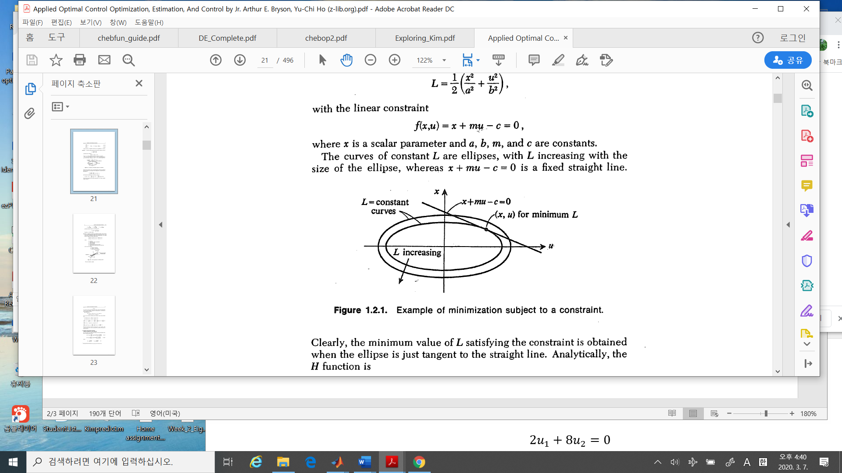

* Procedure to Solution:

1. Define adjoined index $$H\left(x,u,λ\right)=\frac{1}{2}\left(\frac{x^{2}}{a^{2}}+\frac{u^{2}}{b^{2}}\right)+λ(x+mu-c)$$
2. Necessary conditions)
3. $0=\frac{∂H}{∂λ} , -→ x+mu-c=0$: the constraint condition
4. $0=\frac{∂H}{∂x}=\frac{x}{a^{2}}+λ$: the stationary condition w.r.t $x$
5. $0=\frac{∂H}{∂u}=\frac{u}{b^{2}}+λm$: the stationary condition w.r.t $u$
6. Find solutions satisfying a), b) and c)

$$u^{*}=\frac{b^{2}mc}{a^{2}+m^{2}b^{2}}, x^{*}=\frac{a^{2}c}{a^{2}+m^{2}b^{2}}, λ^{*}= -\frac{c}{a^{2}+m^{2}b^{2}}$$

* Ex. 3 : Quadratic Performance Index with Linear Constraint

The quadratic index

$$L\left(x,u\right)=\frac{1}{2}x^{T}Q x+\frac{1}{2}u^{T}Ru$$

With linear constraint

$$f\left(x,u\right): x+Bu+c=0, x∈R^{n}, u∈R^{m}$$

1. Hamiltonian

$H=\frac{1}{2}x^{T}Q x+\frac{1}{2}u^{T}Ru+λ^{T}(x+Bu+c)$

1. The necessary conditions

$$H_{λ}=x+Bu+c=0 \\ H_{x}=Qx+λ=0 \\ H_{u}=Ru+B^{T}λ=0$$

First

$$u= -R^{-1}B^{T}λ, λ=-Qx$$

Together with these

$$λ=QBu+Qc$$

so that

$$u= -R^{-1}B^{T}\left(QBu+Qc\right)$$

simplifying it to get

$$u= -{\left(R+B^{T}QB\right)}^{-1}B^{T}Qc$$

and

$$x= -(I-B{\left(R+B^{T}QB\right)}^{-1}B^{T}Q)c$$

and $$λ={\left(Q^{-1}+BR^{-1}B^{T}\right)}^{-1}c$$

1. The sufficient condition

To verify the minimum, the sufficient condition is

$$L_{uu}|_{f}=R+B^{T}QB>0$$

1. The others which are important

The minimum value is

🡪

* 1. Numerical solution method

1. Gradient descent [data-driven, p125]

To find an extreme, we may use numerical method iteratively. Consider

min $f\left(x\right), x∈R^{n}$

The necessary condition on the extreme is the slope should be zero, i.e.,

$$∇\left(f\left(x^{*}\right)\right)=0$$

The problem is to find $x^{*}$. Let us pick up a point $x_{k}$. Then we decide a next point $x_{k+1}$ so that $f\left(x_{k+1}\right)≤ f(x_{k})$, i.e., to the direction of negative of the slope of $f(x)$

$$x_{k+1}=x_{k} -δ ∇f(x_{k})$$

Here the tuning parameter $δ>0$ should be understood how far move along the gradient curve. It may be optimized. Introduce a new function of $δ$,

$$F\left(δ\right)=f(x_{k+1}\left(δ\right))$$

which is minimized as a function of $δ$.

$$\frac{∂F}{∂δ}=\frac{∂}{∂δ} \left(f\left(x_{k}-δ∇f\left(x_{k}\right)\right)\right)= -∇f\left(x_{k+1}\right)∇f\left(x_{k}\right)=0$$

Now the value $f\left(x_{k+1}\right)-f\left(x_{k}\right)$ is in the admissible bound, the recursive way may be stopped.

1. Newton’s Method {googl}

By Taylor series

$$f\left(x_{k}+δ\right) \sim f\left(x_{k}\right)+f^{'}\left(x_{k}\right)δ+\frac{1}{2}f^{''}\left(x_{k}\right)δ^{2}$$

If the next step is chosen as

$$x_{k+1}=x_{k}+δ$$

Then to optimize to select $δ$

$$0=\frac{d}{dδ}\left( f(x_{k}+δ)\right)=f^{'}\left(x_{k}\right)+f^{''}\left(x_{k}\right)δ$$

which implies

$$δ= -f^{'}\left(x_{k}\right)/f^{''}(x_{k})$$

so that the next step is chosen as

$$x_{k+1}=x_{k} -f^{'}\left(x_{k}\right)/f^{''}(x_{k})$$

In higher dimensional case

$$f^{'}=∇f , f^{''}=∇^{2}f$$

So that

$$x_{k+1}=x_{k}-{\left[∇^{2}f\right]}^{-1} \left(∇f\right)$$